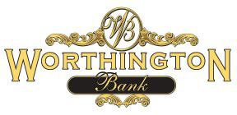

**2020-2022 HMDA Disclosure Statement**

The Home Mortgage Disclosure Act (HMDA) requires to collect and publicly disclose information about housing-related loans and applications for such loans, including several applicant/borrower characteristics. However, Worthington Bank is no longer a HMDA reporting bank for the period of July 1, 2020 through December 31, 2022

therefore, disclosures statements were not available. The Bank was exempt from HMDA reporting due to not meeting origination thresholds.

Institution Name = Worthington Bank

LEI = 254900JWLQKPGK4C0B30